**Part #1**

1. Download files from Blackboard
2. Open command prompt
3. Copy output1 and output2 to the same directory as your command prompt.
4. Copy (type) code from command1.txt into command prompt
5. You should have open line of output

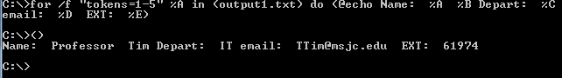

1. Change the file name from output1 to output2 and re-run the code. You should get 3 results this time.

Please create a text file with your name, your student email and this class id

Please create a text file with the modify command needed to run this in command prompt.

Open command prompt and paste your command and confirm that it works.

Email me both of your text files.